MEETING THE HT IN HTML

EXERCISE

Resolve this paths:

Round One: ./images/logo.gif


Round Two: ./../images/logo.gif


Round Three: ./genres/rock/pinkfloyd.html
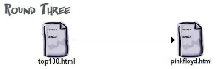

Bonus Round: ./../../images/artists/chris.gif
